Activity No. 4.4
Hands-on Activity 4.4: Characters and Strings
Course Code: CPE007 | Program: Computer Engineering
Course Title: Programming Logic and Design | Date Performed: 9 – 24 – 25
Section: CPE11S1 | Date Submitted: 9 – 25 – 25
Name(s): Paula Esguerra | Instructor: Engr. Jimlord Quejado
6. Output
- Try to create a program that outputs the following?
According to islower:

p is a lowercase letter

P is not a lowercase letter

5 is not a lowercase letter

! is not a lowercase letter

According to isupper:

D is an uppercase letter

d is not an uppercase letter

8 is not an uppercase letter

& is not an uppercase letter

u converted to uppercase is U

7 converted to uppercase is 7

$ converted to uppercase is $

L converted to lowercase is l

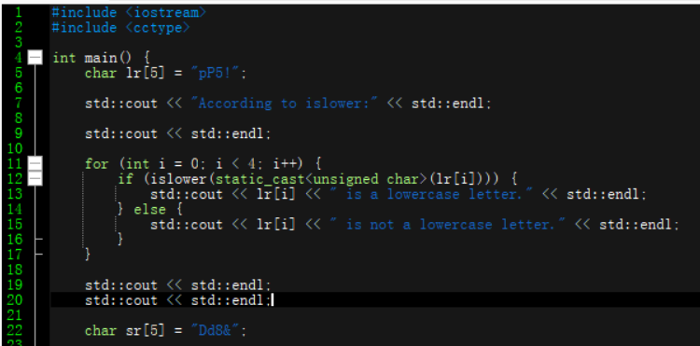
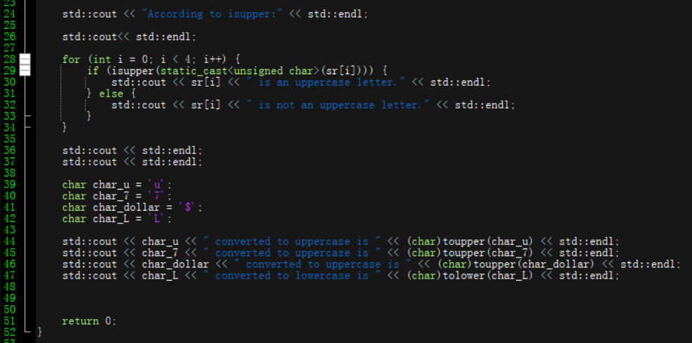
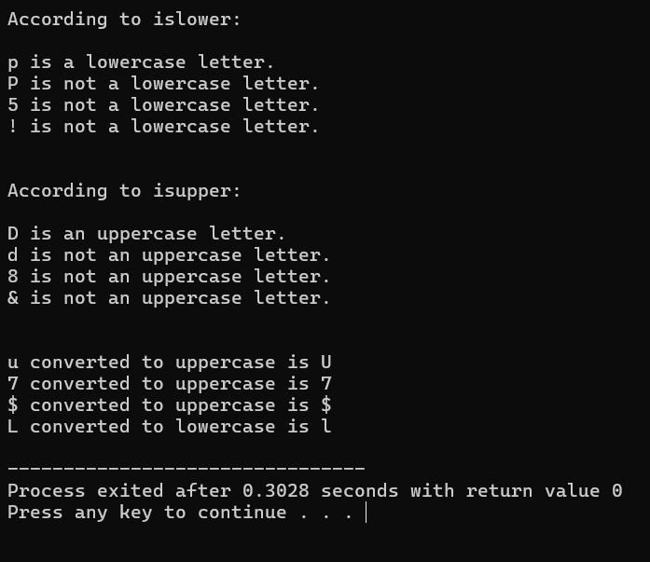

7. Supplementary Activity
- Write a program that inputs a character from the keyboard and tests the character with each of the functions in the character handling library. (Refer to the first Table above)
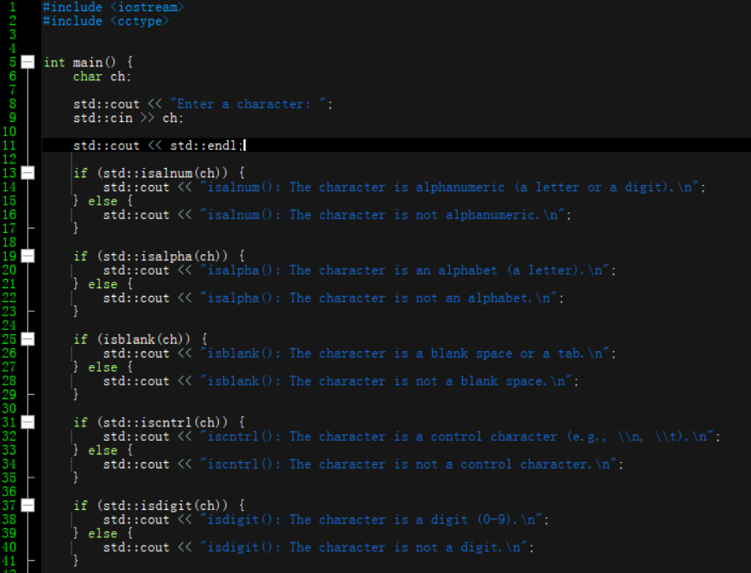
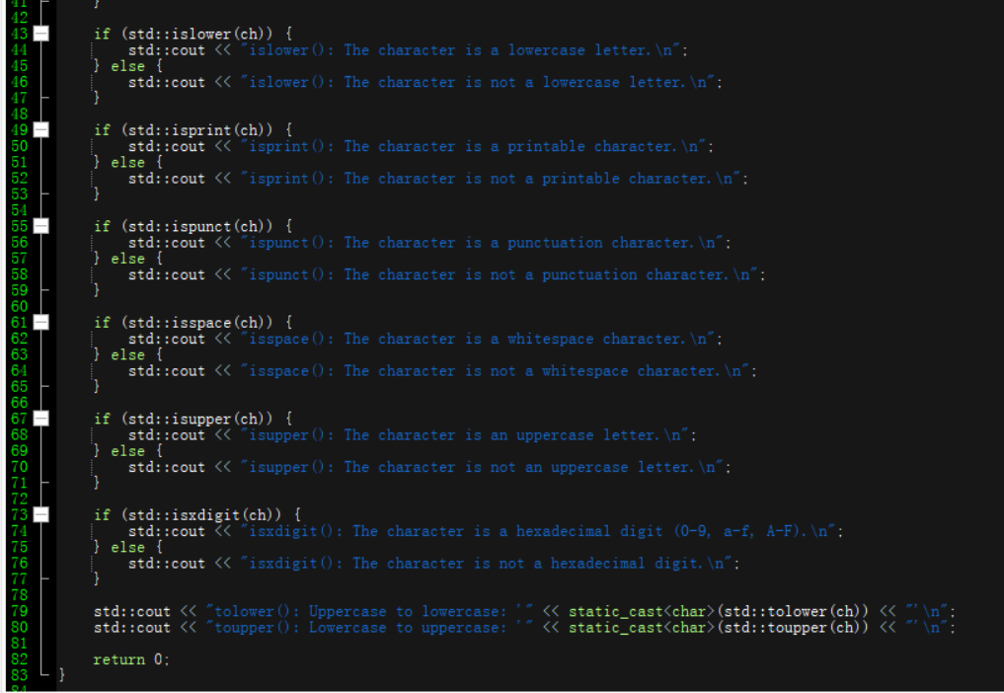
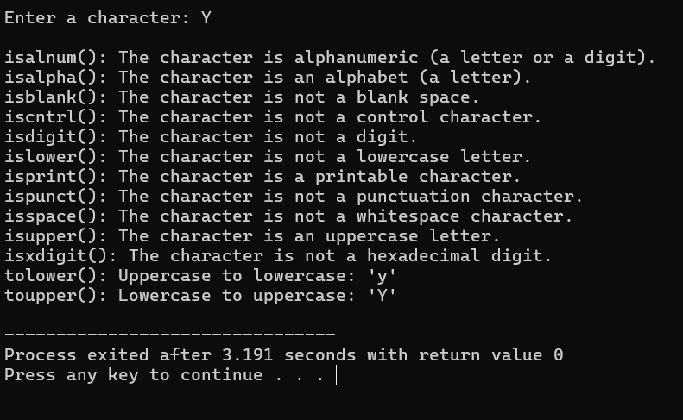
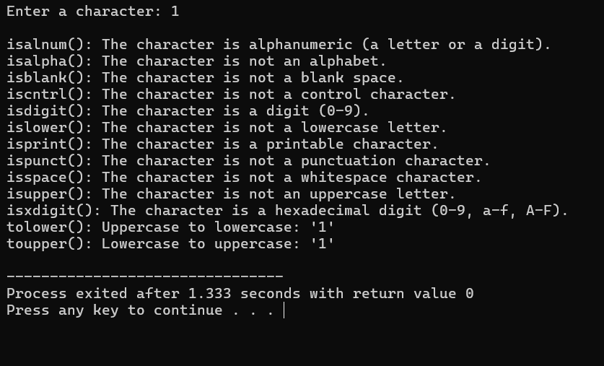
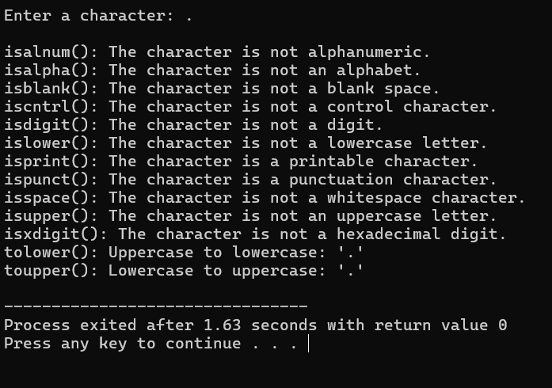
Analysis:
In this program, it considers what is inputted then one by one is analyzed if it is alphanumeric, alphabet, blank space, control character, digit, lowercase letter, printable character, punctuation character, whitespace character, uppercase letter, hexadecimal digit, and prints its upper and lower case at the end. If-else loop was used for it will be analyzed one by one at every step.

3. Write a program that inputs 4 strings that represent integers, converts the strings to integers, sums the values and prints the total of the 4 values.
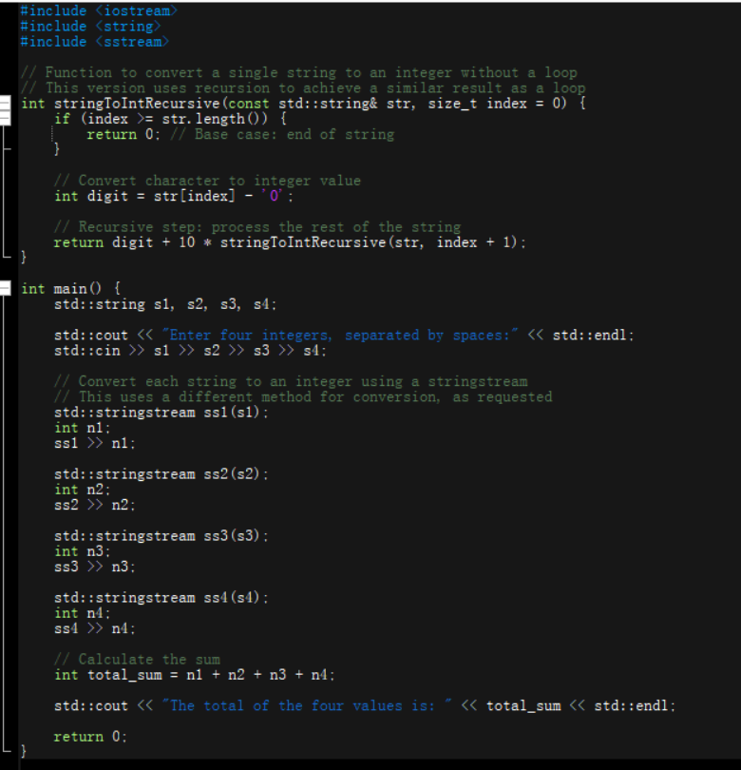
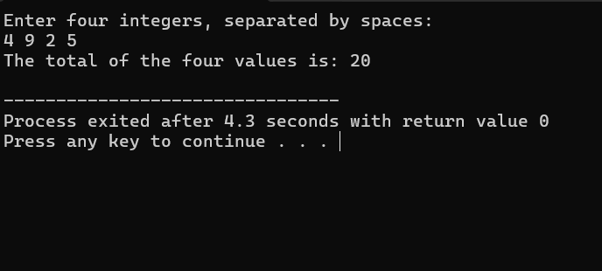
Analysis:
In this code, I have observed from what i searched upon and wanted to try too, that it uses no loop, but it is similiar to where it uses a loop. Then it uses stringstream, where it uses a different method for conversion and calculated the sum.

8. Conclusion
From what I learned, for the first in forever, I got the code I wanted to in the output section, I somehow got the concept of the for loop, also the spaces. Then for the supplementary part, I enjoyed doing no. 2 it analyzes one input then defines them. Then for no. 3, I wanted to explore new codes, so I went a bit different from what we were taught, I am still learning how I did that and how I coded that, but still I learned something new, which is sstream, and the other character handling library.
9. Assessment Rubric

